PLAYER STOCK TIMELINE

This is an example of how a stock grows and drops in price over a period. In this example we will be considering the stats of the NBA season 2016-2017 and 2017-18. For understanding purpose, we will be taking two stocks which show different trends over a period.

We consider a customer with the name Mr. Smith registers with Baller Index as a user before the start of the 2017-2018 NBA season. Mr. Smith is an avid NBA fan and is interested in making an alternate earning option through Baller index. Mr. Smith does his research and identifies two players, whom he firmly believes will improve the coming season. Based on their previous season averages and ESPN player rater Baller Index divides player into different tiers.

Tier 1 - top 50 players - starting price 10$

Tier2 - 50-100 Players- starting price 5$

Tier3 – rest of the players – starting price 2$

Mr. Smith decides to buy stocks of two players. The two players are Andrew Wiggins from the Minnesota Timberwolves and Victor Oladipo who had just been traded to Indiana Pacers.

This is Andrew Wiggin’s stat line from the 2016-17 season.

A screenshot of a social media post

Description generated with very high confidence

He had an elite breakout season averaging close to 24 points a game at above average shooting percentage. The 2016-17 season helped him breakout into the top 50 players in the ESPN Player rater. So, for the price of 10$ Mr. Smith bought 100 shares of Andrew Wiggins.

This was Victor Oladipo’s stat line from the 2016-2017 season.

A screenshot of a social media post

Description generated with very high confidence

Victor Oladipo played for the Oklahoma Thunder in the previous season and under the tutelage of Russell Westbrook who went on to win the MVP of 2016-17 season. Oladipo was then traded in a package which brought the mercurial Paul George to OKC thunder and sent Oladipo to a depleted pacers team where he would have the opportunity to forge his own identity and fame. His subpar stats rank Oladipo 75th in ESPN player rater, Mr. Smith bought 100 shares of Victor Oladipo for 5$.

The total investment of Mr. Smith is

100 shares of Andrew Wiggins X 10$ = 1000$

100 shares of Victor Oladipo X 5$ = 500$

Total investment in Baller Index = 1500$

for 200 shares of two players

Now we simulate 10 games into the season, and using our price determination algorithm and updating averages every 5 games we come up with the new prices of the two players.

First step we take in the data of the stat lines of the two players over the 10 games.

Andrew Wiggins in 10 games

A picture containing wall, train, outdoor, sky

Description generated with high confidence

A close up of several top

Description generated with high confidence

Second step, we then manually calculate the new price of the player after each game. We update the averages of the player after every 5 games to normalize the increase or decrease in price as much as possible to avoid dramatic change in price.

The Manual calculation table –

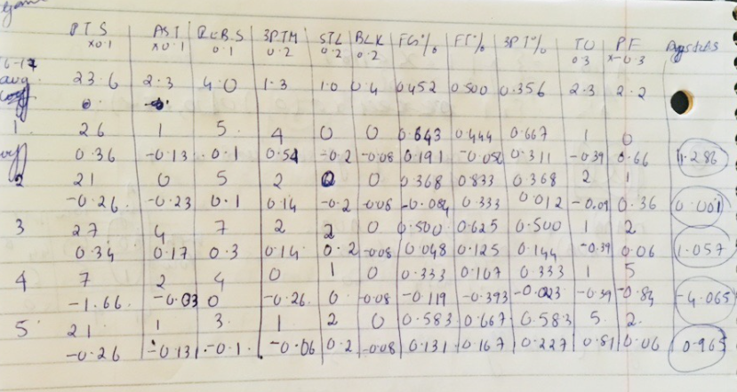A close up of text on a white background

Description generated with high confidence

From the table we can see the change in price of Andrew Wiggins

10$ initial price of 1 share

|  |  |  |  |
| --- | --- | --- | --- |
| GAME NUMBER | CHANGE IN PRICE  (per share in $) | NEW PRICE  (per share in $) | PROFIT/LOSS  (if shares sold in  $ per 100 shares) |
| 1 | 1.286 | 11.286 | 128.6 |
| 2 | 0.001 | 11.287 | 128.7 |
| 3 | 1.057 | 12.344 | 234.4 |
| 4 | -4.065 | 8.279 | -172.1 |
| 5 | 0.965 | 9.244 | -75.6 |
| 6 | -1.22 | 8.024 | -197.6 |
| 7 | -2.2942 | 5.7298 | -427.02 |
| 8 | -1.4488 | 4.281 | -571.9 |
| 9 | -1.4478 | 2.8332 | -716.68 |
| 10 | 0.7946 | 3.6378 | -637.22 |

This table shows what is the profit or loss Mr. Smith would make if he sold his share after each of these 10 games.

Wiggins had a below par season the rapid decline in his price shows his form.

Ideally Mr. Smith has lost money on this investment considering he sold the stock after 10 games a loss of 637.22$ out of 1000$ he invested on Andrew Wiggins.

This dip in form of Andrew Wiggins is primarily due to the addition of Jimmy Butler to the Minnesota Timberwolves thereby limiting his usage and production. This means that Andrew Wiggins has Fallen out of the top 50 players on ESPN player rater and is now ranked 67th and hence making him a tier 2 player.

What is also important to note is we have set his new averages for the season after 5 games, this will happen after every 5 games to stop a total downslide of the stock. By looking at the Stat table you can see that Wiggins gradually started decreasing in production.

Now let us look at how Victor Oladipo fared in his 10 games

A close up of a keyboard

Description generated with high confidence

Now manually calculating his new price after each game and altering his averages after 5 games.

A close up of a map

Description generated with high confidence

From the table we can see the change in price of Victor Oladipo

5$ initial price of 1 share

|  |  |  |  |
| --- | --- | --- | --- |
| GAME NUMBER | CHANGE IN PRICE  (per share in $) | NEW PRICE  (per share in $) | PROFIT/LOSS  (if shares sold in  $ per 100 shares) |
| 1 | 1.914 | 6.914 | 191.4 |
| 2 | -0.794 | 6.12 | 112 |
| 3 | 5.894 | 12.014 | 701.4 |
| 4 | 6.525 | 18.539 | 1353.9 |
| 5 | 2.202 | 20.741 | 1574.1 |
| 6 | -0.644 | 20.097 | 1509.7 |
| 7 | -0.964 | 19.133 | 1413.3 |
| 8 | 0.462 | 19.595 | 1459.5 |
| 9 | 0.983 | 20.578 | 1557.8 |
| 10 | -0.043 | 20.535 | 1553.5 |

This table shows what is the profit or loss Mr. Smith would make if he sold his share after each of these 10 games.

Victor Oladipo had a phenomenal start to the season, he was the break out star in his first 10 games of the season. These 10 games move Oladipo up the ladder in the ESPN player rater to 35th making him a tier 1 player.

Overall Mr. Smith made a huge profit on his 100 shares on Oladipo quadrupling his investment of 500$ to an approximate profit of 1554$.

Another important aspect to take note is that after 5 games his averages have been updated to his current season averages in the first 5 games, this helps us regulate the price of the player and avoid exponential unreal growth or decline of a player. As you can see after 5 games his price normalizes and doesn’t vary too much. This shows that Oladipo improved till a level in terms of stats and only if he surpasses his new averages his price will again increase.

Overall Mr. Smith has done a good investment, all the money he has lost on Wiggins is easily covered by the Oladipo stock.

Important Takes-

* The portfolio of the user will be updated like this after every game, giving the user perspective and making it easier for them to decide on whether to sell or hold on to their shares of the player.
* Another element not taken into price determination is the supply and demand factor, cause for this we would need to consider many users. We already devised a formula which will help us regulate the price of the player depending on supply and demand.

Other Possible scenarios –

* In case of an injury the player price will freeze till he returns.
* In case the player retires then the stock will drop to zero and all owners of the stock will get no money in return.